VySkan
Product Name | 4G LTE Intelligent OBD Vehicle Tracker
Product Model | OBD Standard
Compact. Intelligent. Reliable.
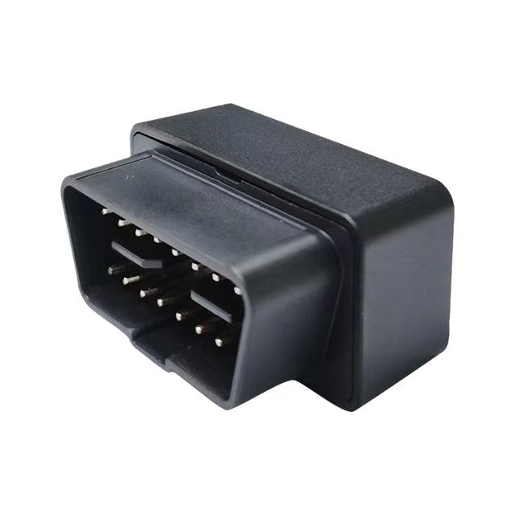
Engineered specifically for auto finance risk management and fleet monitoring, this intelligent OBD terminal delivers uncompromising security and real-time visibility. Its ultra-compact design makes it the smallest in its performance class, perfectly suited for covert installations and seamless plug-and-play deployments.

- Core Value
- Ultra-Compact & Stealth Deployment
With dimensions of just 51mm × 47mm × 23mm, it is designed for highly concealed installations within confined vehicle spaces.
- Intelligent Power Management
A built-in 3D 3-axis accelerometer enables a smart sleep/wake mechanism. When stationary, it drops power consumption to an ultra-low 2.5mA, actively protecting the vehicle's battery while maintaining defense.
- Uninterrupted Trajectory & Data Security
Network blind spots are mitigated by a built-in cache that stores up to 800 data points when cellular connection drops. Combined with cornering compensation logic, it ensures 100% precise route mapping.
- Proactive Asset Defense
Equipped with comprehensive multi-alert systems including low-voltage alarms (triggered after 5 minutes of external power disconnection) , over-speed, and under-speed alerts to ensure maximum fleet safety.

- Target Applications
- Auto Finance & UBI Insurance (Risk management, minimal footprint)
- Corporate Fleet Management (Mileage, speed monitoring, and precise trajectory)
- Car Rental & Leasing (Plug-and-play installation & asset security)

Technical Specifications
  - Cellular & GNSS

Category | Specification | Description
Network Bands | 2G/4G/4G+2G  (GSM,FDD-LTE, TDD-LTE)  (Global/Regional bands optional ) | Flexible network configuration based on client requirements.
GNSS Module | GPS/BDS/ GLONASS | Multi-constellation support for high-performance satellite tracking.
LBS Fallback | Supported | Automatically switches to base station tracking (30s intervals) in GPS blind zones.
Sensitivity | Tracking:-162 dBm | Maintains strong signal lock.
Start Time | Cold: Avg 32s |  Hot: Avg 1s | Rapid satellite acquisition.

  - Power & Electrical

Category | Specification | Description
Operating Voltage | DC 9V - 35V | Wide voltage range compatible with most vehicles.
Working Current | Avg 35mA  (ACC ON) | Standard active tracking mode.
Sleep Current | 2.5mA (ACC OFF) | Ultra-low power consumption mode.

  - Interfaces & Expandability

Category | Specification | Description
Smart Alarms | Low-voltage, Over-speed, Under-speed | Comprehensive built-in alerts for fleet safety and security.
Smart Sensor | Built-in 3D 3-axis Accelerometer | Detects vehicle motion and manages intelligent sleep logic to protect battery life.
Data Cache | Blind Zone Compensation (Up to 800 logs) | Automatically caches trajectory data during GPRS dropouts and uploads upon reconnection.
Protocols | JTT808 / GT06 | Natively supports industry-standard protocols for seamless platform integration.

  - Physical & Environmental

Category | Specification | Description
Dimensions | 51mm × 47mm × 23mm | Smallest in its class for covert installation.
Weight | 53g | Extremely lightweight design.
Housing Material | ABS Plastic | Industrial-grade durability.
Operating Temp. | -25℃ to 75℃ | Reliable operation in varied climates.
- Built for Rapid Integration
- Standard Protocols: Natively supports TCP transmission and offers a choice between standard JTT808 or GT06 protocols.
- OTA Ready: Supports dual-mode remote upgrades (Platform + SMS) to minimize maintenance costs.
- A personalized service prepared for you
- 1× OBD Standard Sample Device (Pre-configured)
- Full API & Protocol Documentation
- 1-on-1 Technical Support from our Field Engineers
- Contact us
Website：https://vyskan.com/
Email: marketing@vyskan.com

